Michie 2011 – The behaviour change wheel: A new method for characterising and designing behaviour change interventions

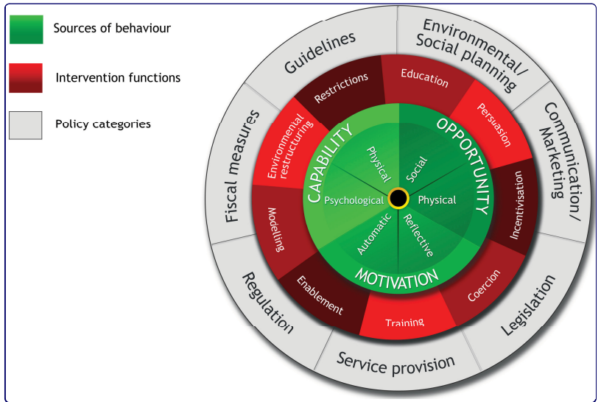

Measurement of behavior change:

Behavior measured in terms of prevalence or incidence in specified population

Interventions used to promote uptake and optimal use of effective clinical services and to promote healthy lifestyles

Process of designing behaviour change interventions:

* Determining broad approach and then working on specifics of intervention design

Effectiveness of intervention may be dependent on the behavioural target, target population, and context

Intervention are often based on theories, but theories do not encompass all possible factors

e.g. Theory of Planned Behaviour and Health Belief Model do not address the important roles of impulsivity, habit, self-control, associative learning, and emotional processing

interventions should be guided by theory!

Plethora of frameworks for classifying behaviour change interventions but none are comprehensive and conceptually coherent

Distinction between population-level and individual-level interventions [13].

But distinction is not coherent and can’t classify all interventions

Most intervention designers do not use existing frameworks as a basis for developing new interventions or for analysing why some interventions have failed while others have succeeded

->one reason may be that frameworks do not meet their needs

a framework for characterising interventions should be comprehensive: should apply to every intervention that has been or could be developed.

The framework needs to be coherent in that its categories are all exemplars of the same type of entity and have a broadly similar level of specifity.

Categories should be from a super-ordinate entity.

The categories should be able to be linked to specific behaviour change mechanisms that in turn can be linked to the model of behaviour.

Aims:

1. Review existing frameworks of behavioural interventions to establish how far each meets the criteria of usefulness, and to identify a comprehensive list of intervention descriptors at a level of generality that is usable by intervention designers and policy makers.

2. Use this list to construct a framework of behaviour change interventions that meets the usefulness criteria listed above.

3. Establish the reliability with which the new framework can be used to characterise interventions in two public health domains.

**Methods:**

COM-B: behaviour is dependent by capability, opportunity and motivation.

capability: individual’s psychological and physical capacity to engage in the activity concerned: includes having the necessary knowledge and skills. Psychological capability being the capacity to engage in the necessary thought processes – comprehension, reasoning

motivation: all brain processes that energize and direct behaviour, not just goals and conscious decision-making. It includes habitual processes, emotional responding, as well as analytical decision-making. Reflective processes (involving evaluations and plans) and automatic processes (involving emotions and impulses that arise from associative learning and/or innate dispositions)

Opportunity: all the factors that lie outside the individual that make the behaviour possible or prompt it. Physical opportunity afforded by the environment and social opportunity afforded by the cultural milieu that dictates the way that we think about things

Opportunity can influence motivation as can capability; enacting a behaviour can alter capability, motivation, and opportunity.

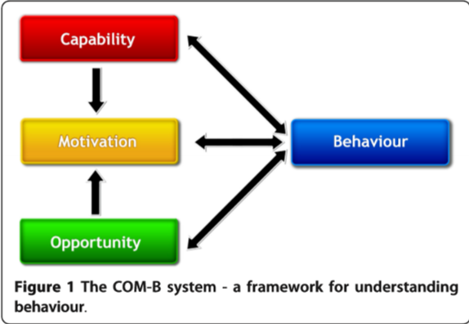

A given intervention might change one or more components in the behaviour system. The causal links within the system can work to reduce or amplify the effect of particular interventions by leading to changes elsewhere.

Basis for designing interventions aimed at behaviour change: Consider what the behavioural target would be, and what components of the behaviour system would need to be changed to achieve that.

The system places no priority on an individual,group, or environmental perspective, all are equal.

For a given behaviour in a given context, it provides a way of identifying how far changing particular components or combinations of components could effect the required transformation.

Within the three components, it is possible to develop further subdivisions that capture important distinctions noted in the research literature.

There is a general recognition that context is key to the effective design and implementation of interventions, but it remains under-theorised and under-investigated

An ongoing programme of research is developing an ‘intervention design tool’ based on the BCW. It starts with a theoretical understanding of behaviour to determine what needs to change in order for the behavioural target to be achieved, and what intervention functions are likely to be effective to bring about that change

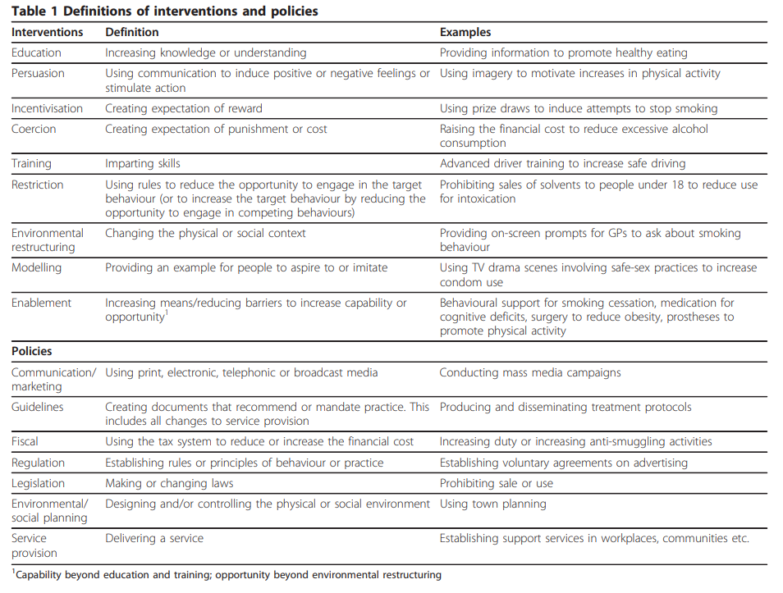

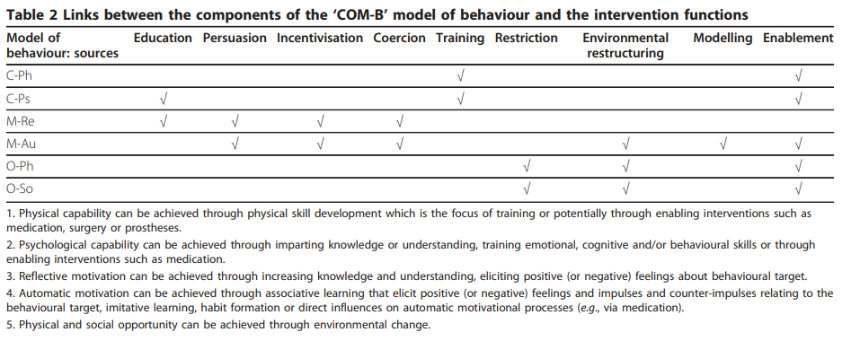

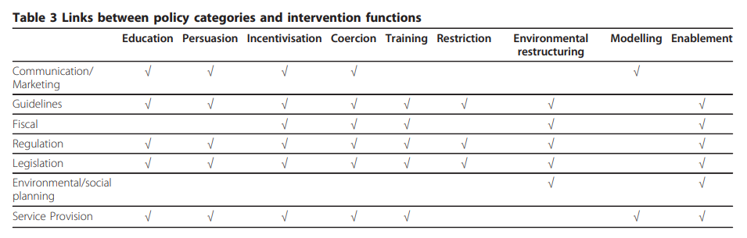

# Literature on flying purpose & frequency and demographics

## Guillen-Royo, 2022

### Theory / Related work

**Practice-theoretical perspectives**

Social practices: routinized types of behaviors, such as commuting, grocery shopping, showering, taking holiday trips, visiting family, etc.

Social practices in flying: reasons why people fly

Aspects of practices (Shove et al., 2012; Shove & Pantzas, 2005)

* Meanings (cultural expectations and conventions)
* Material (technologies, structures, things)
* Competence (embodied skills & knowledge)

Pandemic brutally interfered with status quo practices concerning mobility and people were forced to adapt

**Recent studies on social practices that studied air travel and low-carbon alternatives, videoconferences, or less travel overall**

* Luzecka 2016
* Randles & Mander 2009
* Sahakian et al 2021

Findings on aspects of practices

* Infrastructures (airports, roads, pt stations) & technologies that facilitate remote working important for decision to fly (Jacobson 2020, Mattioli 2021, Sahakian 2021)
  + Additionally, workspace, cleanliness, comfort of type of transport
* Skills and competences: learning skills of “slow travel” (Sahakian 2021), digital skills for virtual exchanges (Denstadli 2004, Mattioli 2016)
* Values & norms: pro-environmental, intrinsic values, implementing regulations forcing businesses to count travel time as working time may dissociate everyday practices from air travel (Büchs 106, Sahakian 2021)
* Economic resources (speculative): make air travel relatively more expensive than other more sustainable counterparts, by subsidizing train journeys or applying higher carbon taxes or levies to frequent fliers

**Other perspectives to induce behavioral change on flying in the literature**

* Attitudes and values supporting air-travel reduction (Büchs 2016; Whitmarsh & O’Neill, 2010)
* Incentives and barriers to reducing flights at the individual and societal level (Frändberg 2014, Jacobson et al, 2020, Mattioli et al 2021)
* Attitude-behavior gap (Kroesen 2013)
* Normative framework that associates flying with necessities (Gösling et al 2019)
* Factors that determine popular support for air-travel restrictions (Kallbekken & Saelen, 2021)

**Max-Neef needs theory (Max-Neef, 1991; Smith & Max-Neef, 2011)**

-

### Methods and data

#### Survey / Quantitative data

Pre-pandemic survey

**Dependent variable**: “How often do you take a train or bus instead of a car or airplane for long journeys (non-regular overnight journeys), likert 0-4

**Independent variables:** elements of practice that may play a part in decision to replace air and car travel with low-carbon alternatives.

#### Qualitative data

Interview with people about the trip from Oslo to Bodo

* Travel biographies
* Supporting elements that they needed to replace flights with train travel or videoconferences
* How these connected with human-needs fulfilment and quality of life

### Results

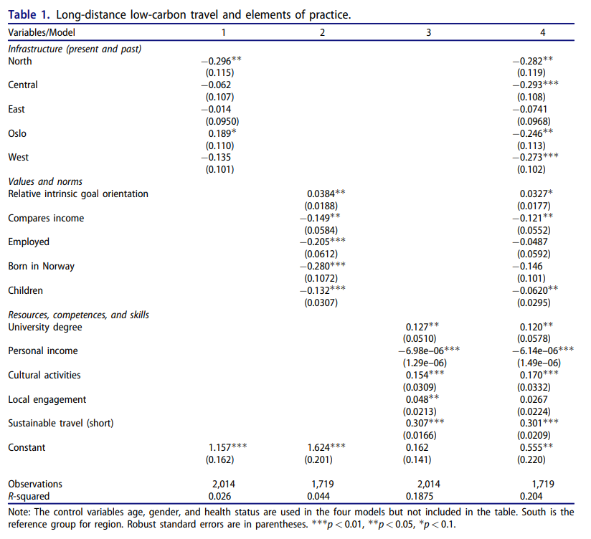

Table 1 shows that elements of practice are relevant to flying behavior

* **Infrastructure** significantly predicted sustainable journey (good infrastructure in south of Norway, terrible infrastructure in north of Norway)
* **Values** had the lowest predictive power
  + Children were used to operationalise convenience and efficiency that justify avoiding sustainable transport alternatives and negatively predicted sustainable travel
* **Resources, competencies, and skills** had the highest predictive value
  + Consumption of cultural events and having a university degree positively associated with more sustainable travel
  + Income strongly negatively predicted sustainable travel
* **Using sustainable transport modes for short-distance** travel positively predicted sustainable long-distance travel

Qualitative data was used to better understand why certain elements were predictive (e.g. having children)

* Before Covid, having a digital meeting between authorities was seen as a sign of lack of respect

Predictors of more sustainable long-distance travel

* Good Infrastructure, access
* Less social comparison
* Less children
* Less wealthy
* Emphasizing intrinsic values
* Having higher social capital
* Engaging in short-distance, sustainable travel

### Take-home messages for further work

* Qualitative work: ask people why they fly, why they drive, and why they take public transport
  + ask about benefits, negative aspect of their chosen mode of transport (ask about each mode of transport to understand when people use them, why they use them and what their experience is like)

## Chalvatzis & Ormosi, 2020; Eriksson, 2020

Flying to conferences

## Randles, 2009 [22]

Social standards of the practice of celebration and pursuing hobbies and interests have become significantly intertwined with taking trips and short break holidays, short and long distance traveling.

Increase in flying trips taken and passenger km distances travelled (Randles & Mander, 2009)

**->read this paper**

## Wormbs & Söderberg, 2021 [11]

Read this paper